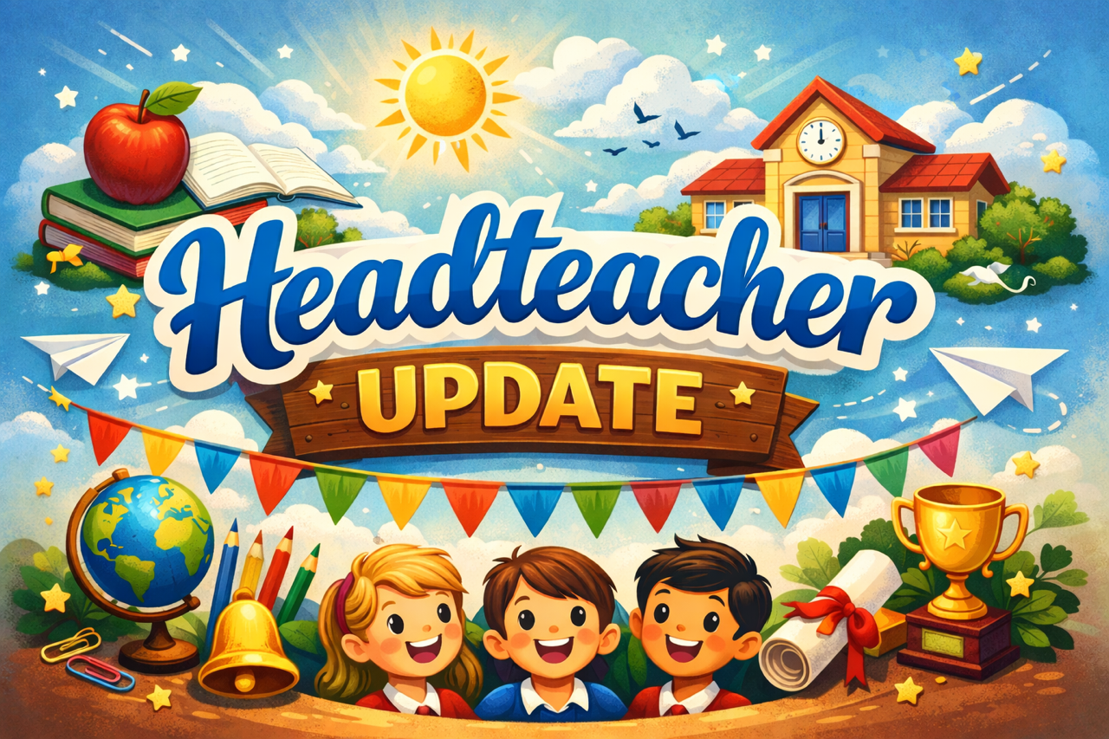

Welcome to this week’s Head Teacher update!
I would firstly like to thank you, our parents. It has been lovely to have so many of you congratulate me on my recent appointment as Headteacher of our wonderful school!
Thank you.

The children have continued with their excellent work in school. It is a pleasure to share some of the highlights with you!

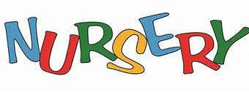
A big thanks to all the parents who attended the Maths session held by Mrs Brown last week. Mrs Brown shared practical ideas and examples of how best to support our children in nursery with maths in everyday life: from till receipts, to cooking, to numbers on buses – maths is everywhere! If you missed the session, don’t worry as the information will be shared electronically. We received very positive feedback from families, and a follow-up session will be coming soon. Please speak to Mrs Brown if you are interested.
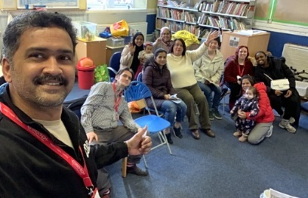
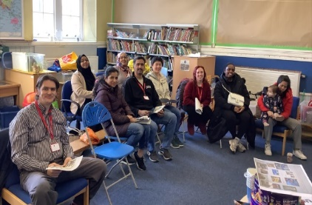

Primary 1 & 2
Primary 1 & 2 have been leading the way with our ‘new’ outdoor learning experiences. They have been outside learning about using our scooters, staying safe and thinking about sharing spaces with others! They look like they are enjoying it.
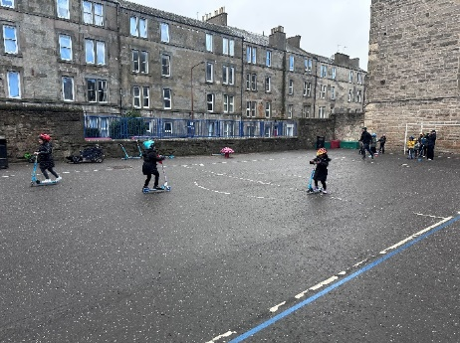
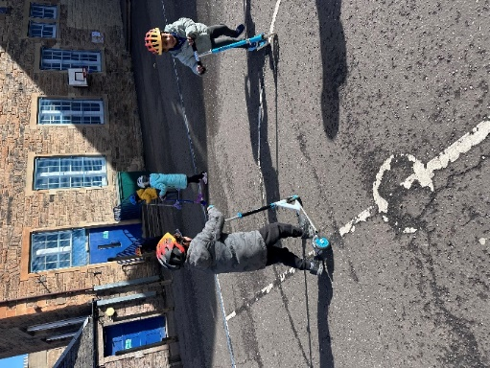

We look forward to seeing our P5 and P6 pupils out on their bikes soon! 
Primary 5
Primary 5 have been thinking about climate change. They came up with some fantastic ideas that could support us all to make changes to support the environment. The children put their ideas in writing and sent these off to influential figures. The school was excited to see that they received a response from many councillors and the King! It was lovely for the children to read that King Charles acknowledged both their ideas and our wonderful school!

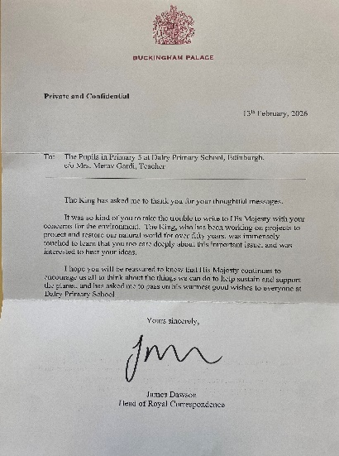

Primary 7 
Primary 7 enjoyed a trip to Dynamic Earth where they got the chance to meet scientists, engineers and technologists from a wide range of STEM sectors and exhibitors from Nature Scot, Scottish Association for Marine Science and the Royal Observatory. The children also learnt about AI for the future of space exploration
Junior Road Safety Officers 
Our junior road safety officers (JRSO) presented to us at assembly this week. Unfortunately, too many of our pupils are still running out into the roads after school. We did have a near miss this week which gave us all a fright in school! Whilst our JRSO’s did a fantastic job reminding our school about safe crossing, we hope you too can remind your children about how to cross safely.

Eid Celebrations 
On Wednesday 1st April (3:30pm – 4:35pm) the school will play host to our Annual Eid celebration. Everybody is welcome, we are looking forward to celebrating together! Please see the parent pay notification for further information.

