Dear Parents, Carers and friends of our school,
Welcome to the very first edition of the Dalry Primary School parent and carer update.
We are excited to start this new way of sharing news, celebrations and updates from across our Edinburgh school community. Here at Dalry Primary, we focus on helping our children stay curious, confident and kind. This newsletter aims to give you a window into the learning, achievements, and experiences that make our school so special.
We value the strong partnership we have with you, our families as well as our wider community. It is hoped that you will find this newsletter not only keeps you informed but gives you a sense of involvement and connection to Dalry Primary School. From classroom highlights to important dates and upcoming events, we look forward to celebrating our journey together.
Thank you for being part of Dalry Primary School. We look forward to sharing many more stories with you in the months ahead.
Martyn Wood (Head Teacher (Acting)

Davy the Dalry Dog!
Dalry Primary School now has our very own school mascot.
A West Highland Terrier, named Davy!
Davy was designed by our pupils, following a small competition to invent a mascot for our school. We had many great entries from across the school. Our Clan chiefs met and searched our entries for a winner. The children were stuck on two similar designs, eventually coming up with the idea to merge them!

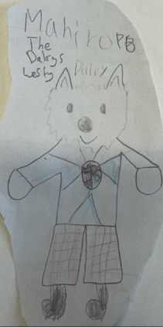
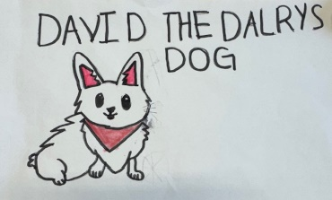

We used a design friend of, Mr Wood to support us in making the design come to life! We think he looks fabulous!
Davy will be a regular part of our weekly assembly, helping us to remember the school values!
Homework Club 
Did you know that the school offers a homework club? WE DO! If your child is finding their homework tricky or it is difficult to get them to do it at home, pop along and speak to your child’s class teacher and ask them about your child attending homework club. Homework club is on a Monday and Wednesday where Mrs Smith is available to help. (Please remember that this is for children who really need support. It is not an after school care club).

Mobile Phone Survey 
The City of Edinburgh council are conducting a survey on the uses, restrictions and storage of mobile phones in schools. Before any decisions are made, they would like your views AND that of your child/ children.
If you can, please follow the link below and complete the survey and support the council in making the right decision for our children.
Parents/carers:
Mobile Phones in Schools - Parent/Carer survey - City of Edinburgh Council - Citizen Space
Pupils:
https://consultationhub.edinburgh.gov.uk/cf/7c310789/

Sorries Assembly and drumming sessions
Yesterday, as part of our Scots focus and celebration of Robert Burns, we welcomed the Scottish musical duo, ‘The Sorries’. Martin, a member of the duo, took a lot of our children through a lesson on the Bodhran drum as well as sharing some fantastic Scottish songs. This culminated in a fantastic whole school assembly where our pupils shared excellent poems, sang Scottish songs and heard ancient Scottish tunes!
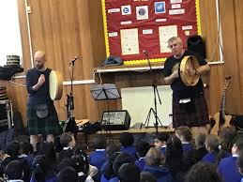
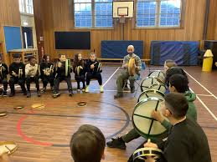

Nursery 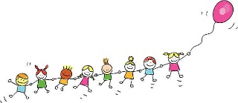
Screen time for young children

It's hard to avoid screens in our daily lives but how much is too much
for young children? There are new pages on screen use for babies and
toddlers in the Development & Growing Up section in the Parent club
website.
Screen use for toddlers aged 2-4 | Parent Club
