Come along to a Peep group
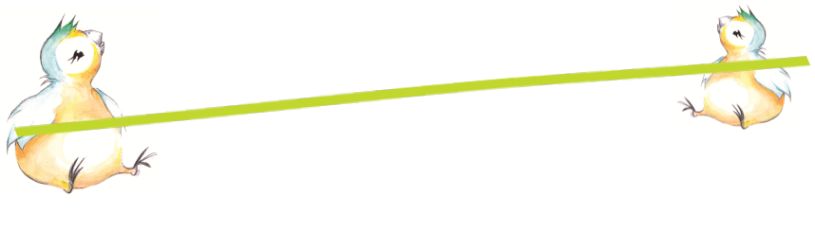
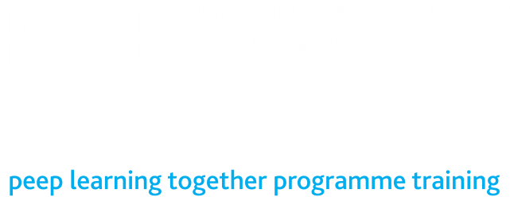

Peep sessions share simple ways of supporting your child’s learning and development in everyday life.


You can make a real difference just by talking, singing, sharing books and playing together.
Come along - you and your child can make friends, share ideas and have fun through singing, story and activities.
Who for | Where | When | Start date | Who to contact
Parents / carers and wee ones from birth to age two | Westerhailes Education Centre, Conference Room 3 | Wednesdays 10am to 11am | Wednesday 19th April | Vanessa  07526 460 616 or,  Angela  07359 308 045
Parents / carers and wee ones from age one to two | Pentland Community Centre, Oxgangs Brae, Edinburgh EH13 9LS | Wednesdays 9.30am - 10.30am | Wednesday 26th April | andrena.graham@ea.edin.sch.uk
Parents / carers and babies up to 12 months | Pentland Community Centre, Oxgangs Brae, Edinburgh EH13 9LS | Fridays 9.45am - 10.45am | Friday 28th April | andrena.graham@ea.edin.sch.uk
Parents / carers and babies from 4 to 12 months | Tynecastle Community Wing, McLeod Street  EH11 2ND | Tuesdays 11:00am – 12:00pm | Tuesday 9th May for 8 weeks | nancyl@homestartedinburgh.org.uk
Parents / carers and babies from 4 to 12 months | Rannoch Community Centre, 6 Rannoch Terrace, EH74 7ER | Wednesdays 1:30 – 2:30pm | Wednesday 10th May for 8 weeks | nancyl@homestartedinburgh.org.uk



