EASY BREAD
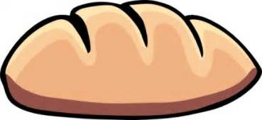

Servings: 1 1/2lb loaf
or 4 small rolls
Ingredients
- 3 cups strong bread flour
- pinch of salt
- 1 packet of quick action yeast
- 2 tablespoons of vegetable or sunflower oil
- 1 cup of warm water (hand hot)
- 1 tablespoon of sugar or honey
Instructions
- Put the dry ingredients in a bowl and mix.
- Make a well in the centre of the bowl
- Add in the vegetable oil and the warm water
- Mix with a spoon until a dough is formed
- Turn out the dough on a lightly floured surface
- Knead for 5 - 10 minutes until smooth
- Make into shapes or put in a loaf tin
- Leave in a warm place for around an hour until doubled in size
- Decorate if you wish
10. Preheat the oven to 180C
11. Cook 15 - 20 minutes for shaped rolls or 20 - 30 minutes
for loaves
12. Test to see if cooked by tapping the bottom with your
knuckle - hollow sound = cooked
13. Leave to cool and enjoy

Bread Recipe Ingredients

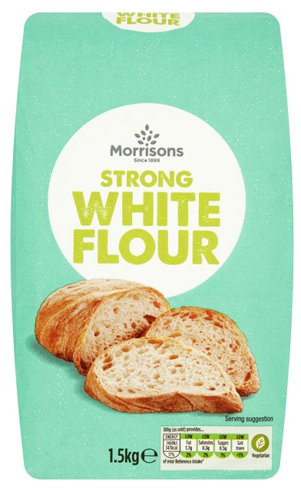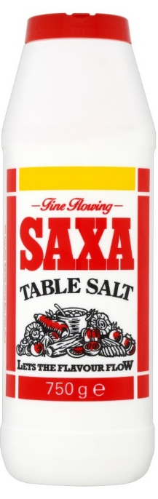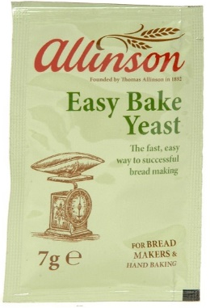
750 grams strong flour 2 tsp salt 1 sachet yeast

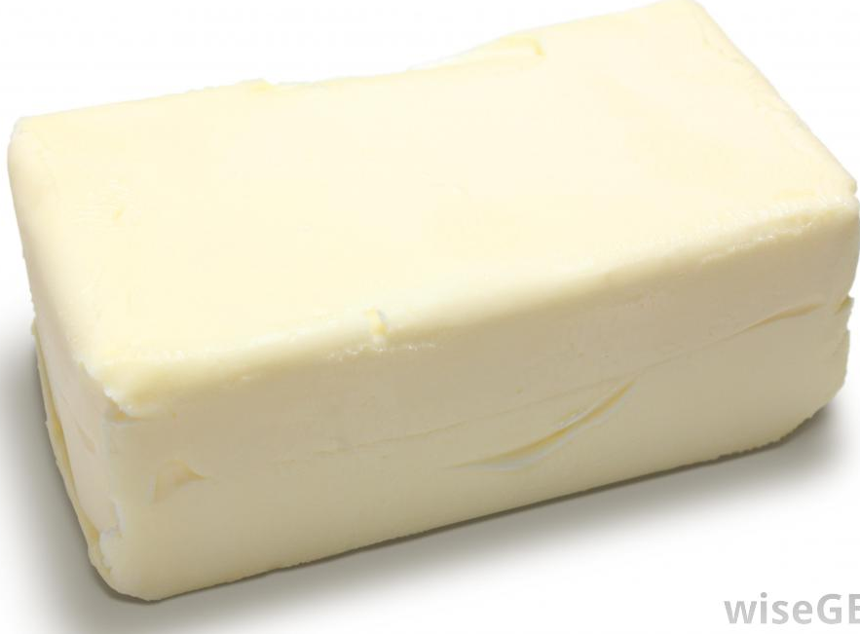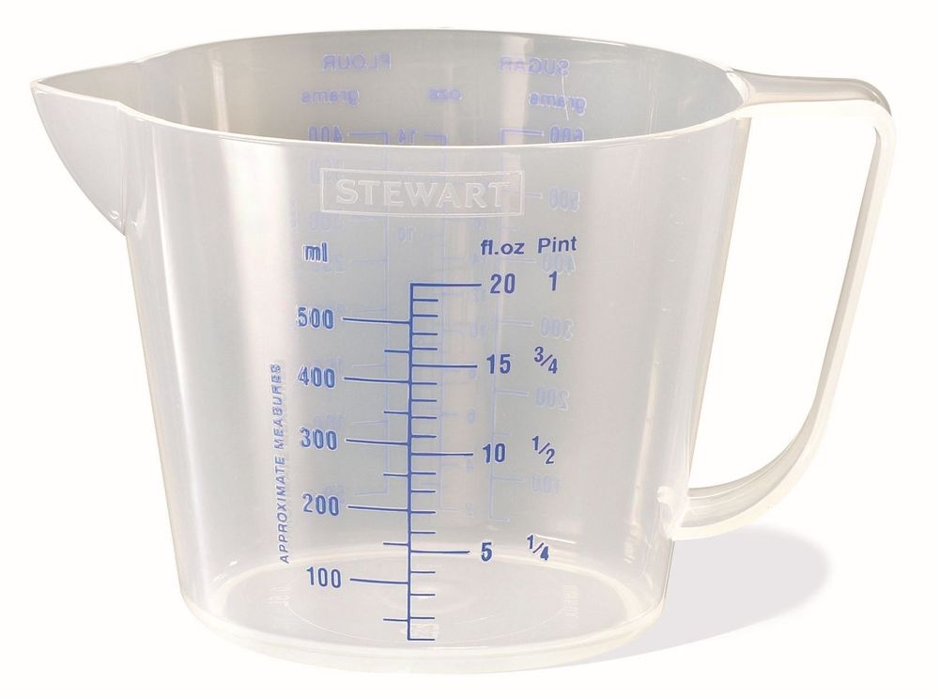

25 grams vegetable lard ¾ pint warm water

